# Phase3:

**AIR QUALITY MONITORING**

IoT devices and then developing a Python script on the IoT

Devices as per the project

# Introduction:

# Air quality monitoring is crucial for safeguarding human health and the environment. Poor air quality can lead to a wide range of health problems, including respiratory diseases, cardiovascular issues, and even premature death. Additionally, it can have detrimental effects on the ecosystem, agriculture, and infrastructure. To address these concerns, the integration of Internet of Things (IoT) technology into air quality monitoring has emerged as a game-changing solution

# Microcontroller Naming:1.ESP32:

It is a successor to ESP8266 SoC and comes in both single-core and dual-core variations of the Tensilica’s 32-bit Xtensa LX6 Microprocessor with integrated Wi-Fi and Bluetooth.

# 2.Arduino uno:

Arduino UNO is a microcontroller board based on

The ATmega328P. It has 14 digital input/output pins (of which 6 can be used as PWM outputs), 6 analog inputs, a 16 MHz ceramic resonator, a USB connection, a power jack, an ICSP header and a reset button. It simply connect it to a computer with a USB cable or power it with a AC-to-DC adapter or battery to get started.

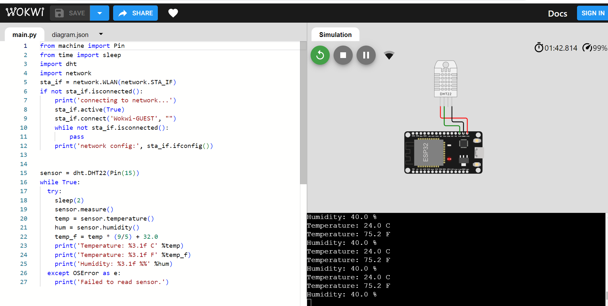

# Program:

# PYTHON CODE

# import time

# import Adafruit_DHT # If using a DHT sensor

# import RPi.GPIO as GPIO # If using a Raspberry Pi

# # Initialize the sensors

# # For gas sensors, you will need specific libraries for your sensors

# # The following is an example for a DHT22 temperature and humidity sensor

# DHT_SENSOR = Adafruit_DHT.DHT22

# DHT_PIN = 4 # GPIO pin number where the DHT sensor is connected

# # Initialize IoT connectivity (e.g., MQTT, HTTP, etc.)

# # You'll need an IoT platform to send data to

# def read_gas_sensor():

# # Use your gas sensor library to read values

# # Example:

# gas_value = your_gas_sensor.read_value()

# return gas_value

# def read_temperature_humidity():

# # Read temperature and humidity from the DHT sensor

# humidity, temperature = Adafruit_DHT.read(DHT_SENSOR, DHT_PIN)

# return temperature, humidity

# def send_data_to_iot_platform(data):

# # Implement IoT platform communication here

# # Example: MQTT, HTTP, etc.

# pass

# while True:

# gas_data = read_gas_sensor()

# temperature, humidity = read_temperature_humidity()

# # Create a JSON payload with the sensor data

# sensor_data = {

# "gas_value": gas_data,

# "temperature": temperature,

# "humidity": humidity

# }

# # Send the data to the IoT platform

# send_data_to_iot_platform(sensor_data)

# time.sleep(60) # Adjust the interval as needed (60 seconds in this example)

# WOWKI CODE :

# from machine import Pin

# from time import sleep

# import dht

# import network

# sta_if = network.WLAN(network.STA_IF)

# if not sta_if.isconnected():

# print('connecting to network...')

# sta_if.active(True)

# sta_if.connect('Wokwi-GUEST', "")

# while not sta_if.isconnected():

# pass

# print('network config:', sta_if.ifconfig())

# sensor = dht.DHT22(Pin(15))

# while True:

# try:

# sleep(2)

# sensor.measure()

# temp = sensor.temperature()

# hum = sensor.humidity()

# temp_f = temp * (9/5) + 32.0

# print('Temperature: %3.1f C' %temp)

# print('Temperature: %3.1f F' %temp_f)

# print('Humidity: %3.1f %%' %hum)

# except OSError as e:

# print('Failed to read sensor.')

**Components:**

**1) Humidity Sensor:**

A humidity sensor is an electronic device that measures the humidity in its environment and converts its findings into a corresponding electrical signal. Humidity sensors vary widely in size and fu | A humidity sensor is an electronic device that measures the humidity in its environment and converts its findings into a corresponding electrical signal.

**2) Temperature Sensor:**

A temperature sensor is a device used to measure temperature. This can be air temperature, liquid temperature or the temperature of solid matter.

**3) gas sensor:**

Gas Sensor is the core of the gas detection system and is usually installed in the detection head. Essentially, a gas sensor is a converter that converts a certain gas volume fraction into a corresponding electrical signal.

# 4) Data Logger:

This component stores the data collected from the sensors for further processing and analysis.

# 5) Microcontroller

It processes the data from the sensors and communicates with the data logger. It might also handle data transmission to a cloud storage system for long-term data storage.

.